**Expt-4:**

**Program:**

import pandas as pd

import matplotlib.pyplot as plt

df = pd.read_csv("./titanic.csv")

pd.read_csv("./titanic.csv")

df.head()

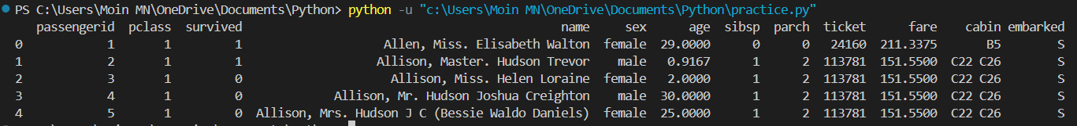

df.isnull().sum()

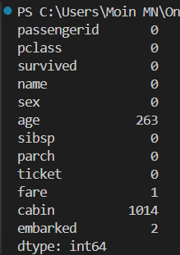

df['age'].fillna(value=df['age'].mean(), inplace=True)

df['fare'].fillna(value=df['fare'].mean(), inplace=True)

df['embarked'].fillna(value=df['embarked'].mode()[0], inplace=True)

df.drop(labels = ['cabin', 'name', 'ticket'], axis= 1, inplace=True)

df.head()

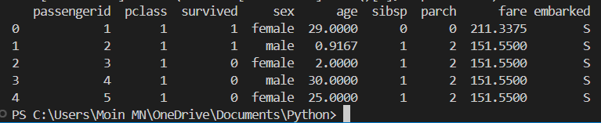

df = pd.get_dummies(df, columns=['sex', 'embarked'], drop_first = True)

df.head()

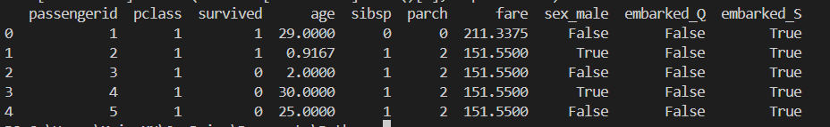

from sklearn.model_selection import train_test_split

X = df.drop('survived', axis=1)

y=df['survived']

X_train, X_test, y_train, y_test = train_test_split(X, y, test_size=0.2, random_state=42)

from sklearn.linear_model import LogisticRegression

model = LogisticRegression (max_iter=1000)

model.fit(X_train, y_train)



y_pred = model.predict(X_test)

from sklearn.metrics import accuracy_score, confusion_matrix, classification_report

print (f"Accuracy: {accuracy_score (y_test, y_pred)}")

print (f"Confusion Matrix: \n{confusion_matrix(y_test, y_pred)}")

print (f"Classification Report: \n{classification_report (y_test, y_pred)}")

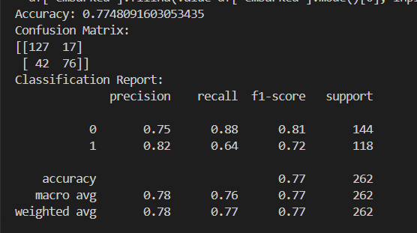

import tkinter as tk

from tkinter import ttk

from sklearn.metrics import classification_report

import matplotlib.pyplot as plt

from matplotlib.backends.backend_tkagg import FigureCanvasTkAgg

root = tk.Tk()

root.title("Logistic Regression Results By Moin MN 211P030")

report = classification_report (y_test, model.predict(X_test), output_dict=True)

report_text = pd.DataFrame (report).transpose().round(2).to_string()

text = tk. Text (root, height=10, width=60)

text.insert(tk. END, report_text)

text.pack()

gender_label = ttk. Label(root, text="Select Gender: ")

gender_label.pack(pady=5)

gender = ttk.Combobox (root, values=["male", "female"])

gender.pack(pady=5)

pclass_label = ttk. Label(root, text="Select Pclass:")

pclass_label.pack(pady=5)

pclass = ttk.Combobox (root, values=[1, 2, 3])

pclass.pack(pady=5)

def show_survivors():

  filtered = data[(data['sex'] == gender.get()) & (data['pclass'] == int(pclass.get())) & (data['survived'] == 1)]

  result_text = f"Survivors: {len(filtered)}"

  result_label.config(text=result_text)

button = ttk.Button(root, text="Show Survivors", command=show_survivors)

button.pack(pady=10)

result_label = ttk. Label(root, text="")

result_label.pack(pady=5)

root.mainloop()

